- Error message for input field validation in referee wallet address is not quite showing or can be seen immediately by the user completely. It should specify the input field (referee wallet address).

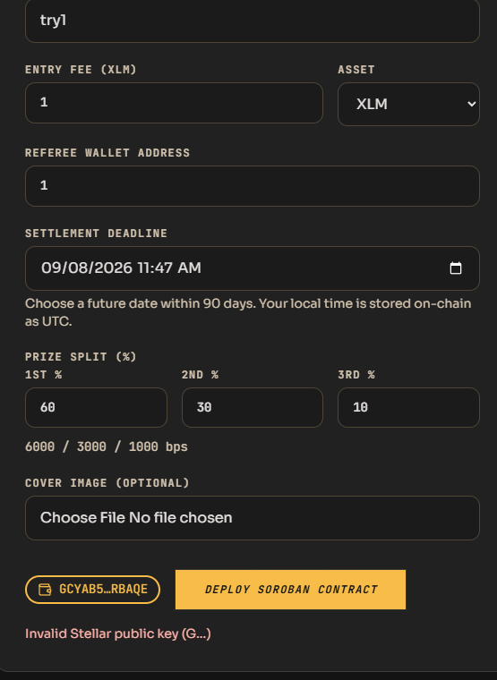

- I tried to logout the account then clicked back button of the browser, the Create tournament form still shows (should have shown a “Need to Login” message). Still tried to fill the Create tournament form, after I complete the input details, when I click the Deploy Soroban Contract button, it shows unexpected token “M” error instead of “Need to Login” like message.
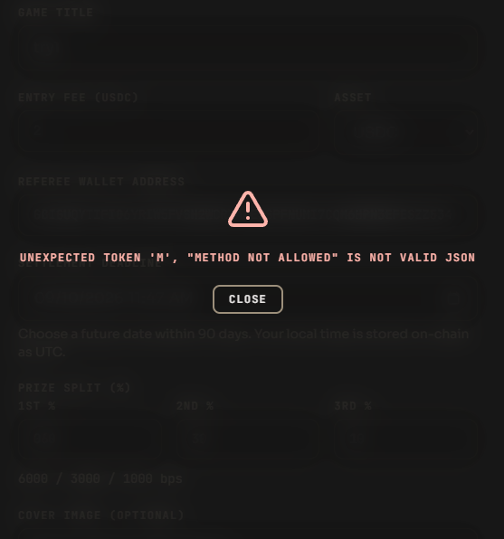

- After connecting a wallet, the connect wallet button should still be available so that the user can still change wallet address without refreshing the browser.

4. Refreshing the browser clears the user inputs, the user inputs should remain even the browser reloads.
5.Organizer and referee can participate once, I tried to submit for 2nd entry for both organier and referee and the error message shown is “Submit failed: 502” instead of specific error such as “You are already a participant”.

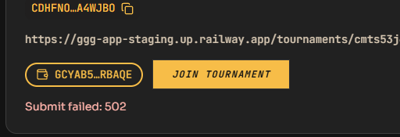

- What timestamp do the system use?
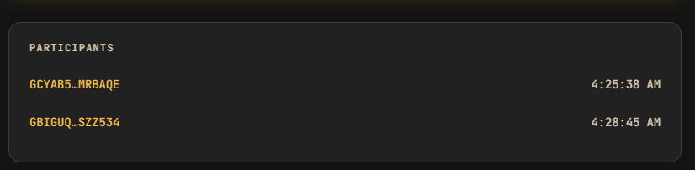

- File Upload Validation Error message, I tried to upload a pdf file and the error message instead of “Invalid file type” like message it shows [object Object]. Also even I uploaded a pdf file it is still accepted by the system and the tournament is created (Prone to malicious file upload).
